**Integrity Checking**

**R. Harini**

**18BCE1010**

1. **Original PowerPoint**

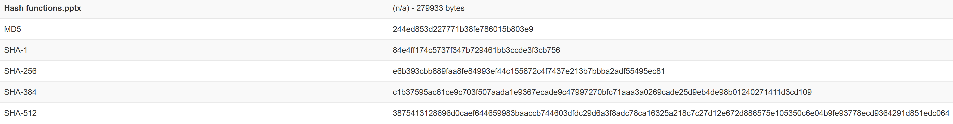

MD5: 244ed853d227771b38fe786015b803e

**Modified PowerPoint**

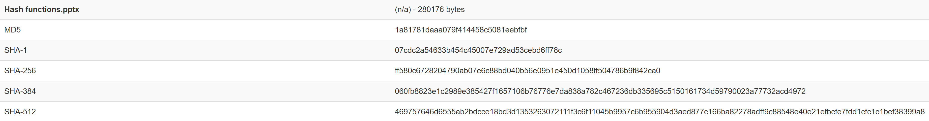

MD5: 1a81781daaa079f414458c5081eebfbf

1. **Original Image**

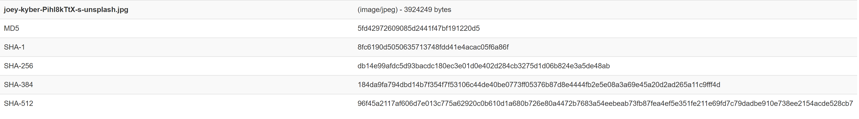

MD5: 5fd42972609085d2441f47bf191220d5

**Un-modified Image**



MD5: 5fd42972609085d2441f47bf191220d5